For some extra activities to keep you going, log into your Purple Mash.

For Science try and create a fair test experiment or research scientists through the years.
If Art is what you are after you might want to design a flag or draw on 2Paint.
If you’re a real whizz with computing then give 2Code a go where there are lots of challenges and activities to accomplish.

Have fun and let us know what your favourite activity was!

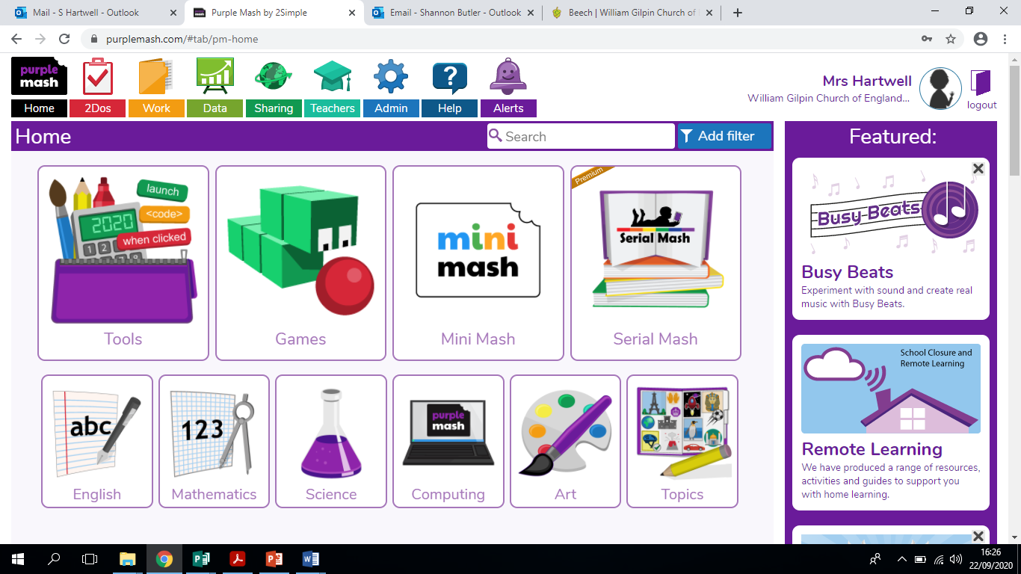
Happy coding!

