Reading

Hello Maple Class! 😊
I have set up a class login on the Oxford Owl website so that everyone can access books for free online. I have been exploring and there are even audio books available!

All you need to do is click on the link below:
https://www.oxfordowl.co.uk/

Then click on My Class Login
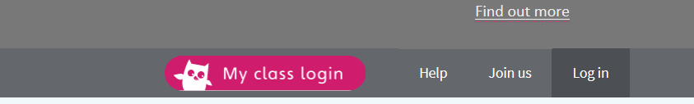

Then enter the login details which are:
Class Name: maple20
Class Password: maple20

Then click on My Bookshelf and search for the book you would like. Happy Reading 😊


